Installation Guide

To successfully run our program, Paddle Wars: Paddle’s of Fury, you must have a Java Runtime Environment installed on your operating system.

In terms of hardware, you require a standard US keyboard and a one or more button mouse.

Installation Walkthrough
1. To obtain a copy of the Java Runtime Environment click the link below,
http://java.sun.com/j2se/1.4.2/download.html

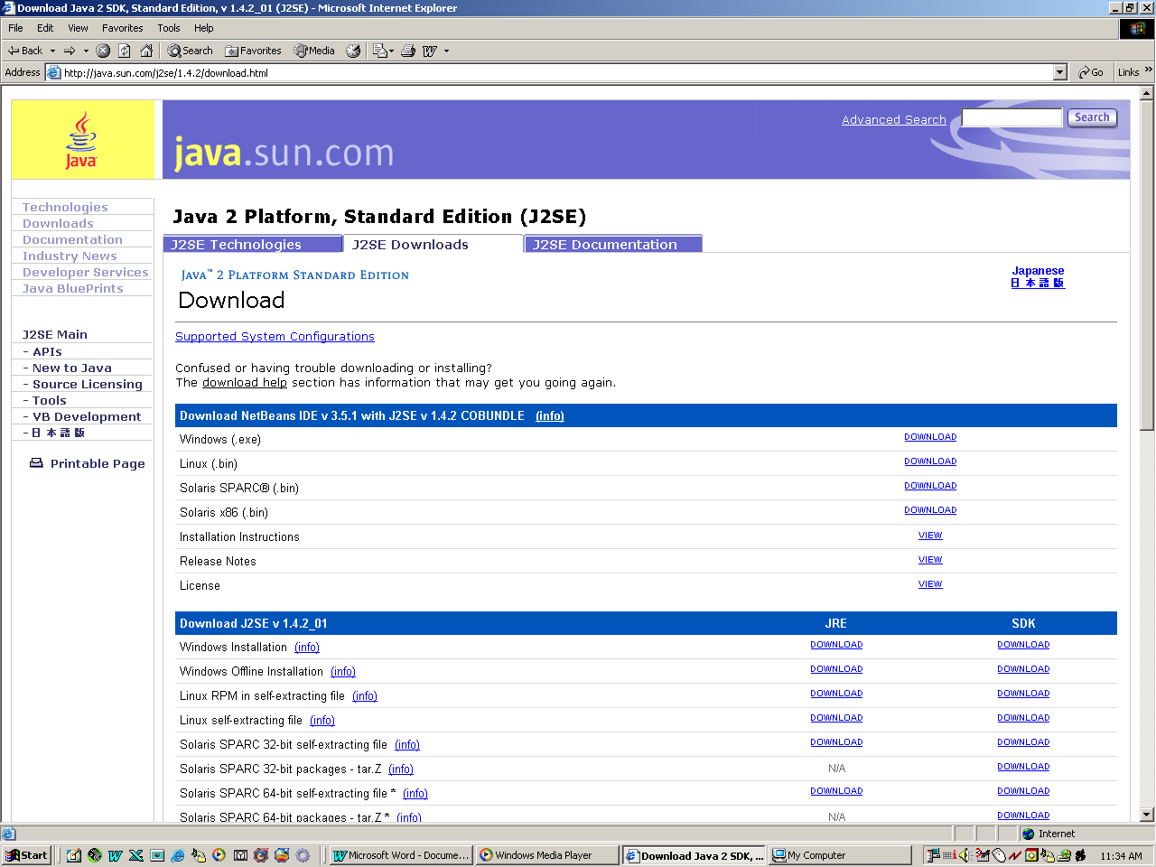
An example of this web page is above.

2. After locating your operating system, click the DOWNLOAD button under the JRE category.
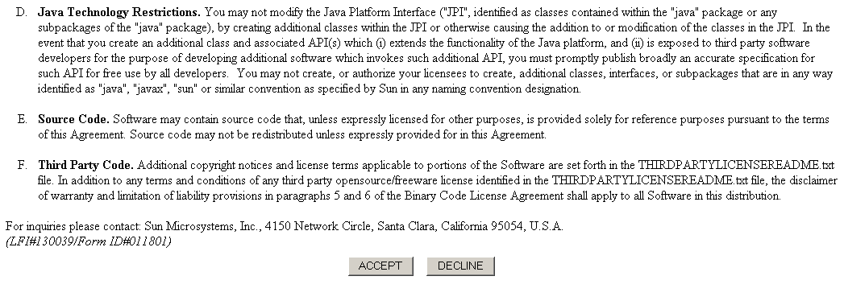
3. A disclaimer is provided by the Java website. If your require to read a copy, do so and click ACCEPT when your finished.

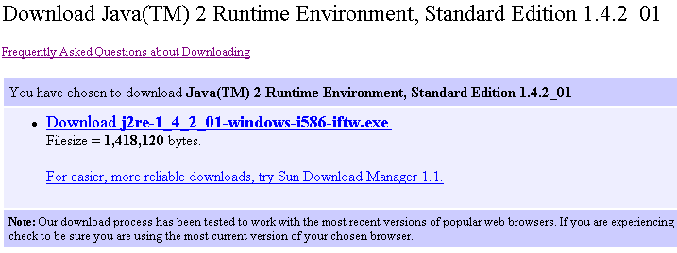
4. You are then provided with a link for the Java Runtime Environment.

This installation includes a web plugin, which enables you to view Java Applets. This is necessary, as we have chosen to use an Applet rather than an Application.

After installation is complete, you will be ready to preview our Java game.

The website which contains our Java game is the following.
http://members.optusnet.com.au/otta2/

Later it will be,

http://www.paddlewars.tk/

Trouble Shooting
- To trouble shoot installation problems, first you must check the size of your file you have downloaded. Some operating systems will report the downloaded file size in kilobytes instead of bytes. To convert the size in kilobytes into bytes, multiply the number of kilobytes by 1024. If the file size still does not match, the file may have gotten corrupted during the download. If you are connected to the Internet via a proxy server, we recommend bypassing the proxy if at all possible for the duration of the download, as some proxy servers attempt to modify incoming bits. If re-downloading does not help this, you may not be able to view our project until you can install the Java Runtime Environment.

- A specific screen size must be larger than 800 by 600 pixels. If you have trouble viewing our program it may be due to this fact. Try resizing the desktop of your computer.
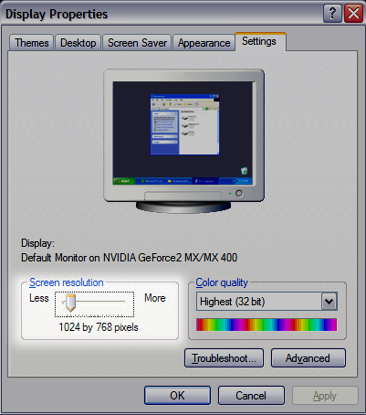

- Another alternative solution is to install a previous version of the Java Runtime Environment. This option allows virtually the same Java code to be used but may bypass any incompatibility problems that your encountered with the latest version.

- 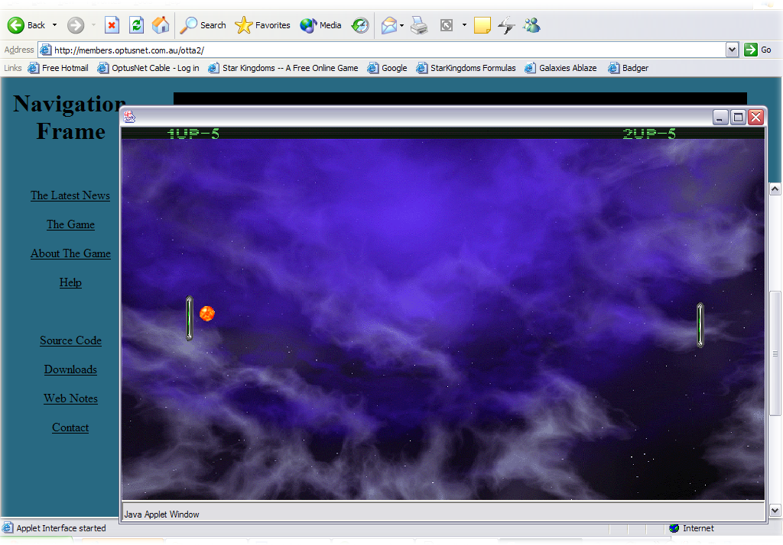
This is an expected screenshot of what our program will look like on the desktop. It will have a frame protruding from the website, this will be the actual game.

